INSTALL JENKINS

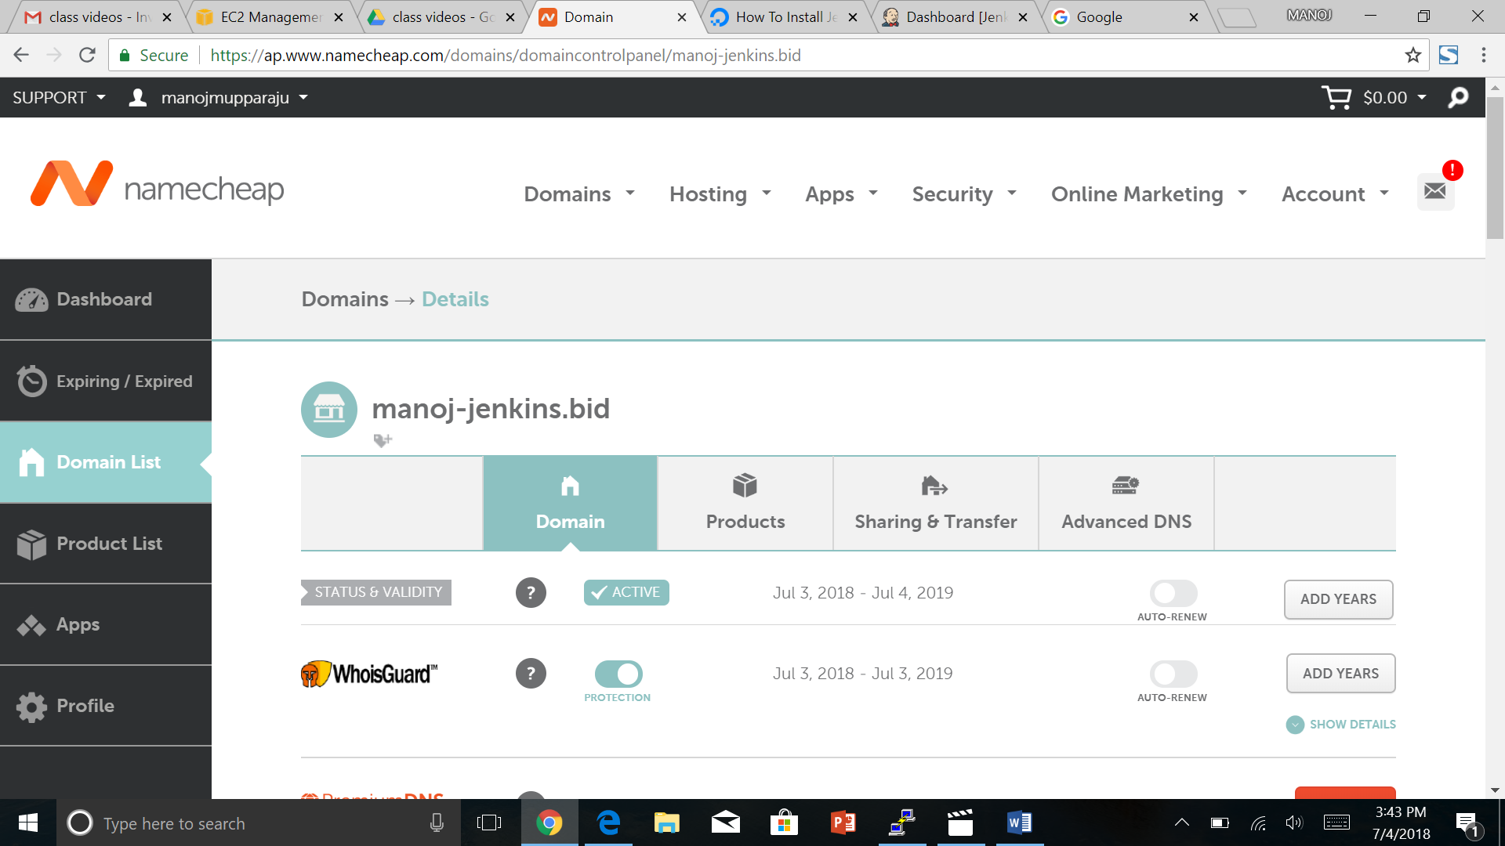

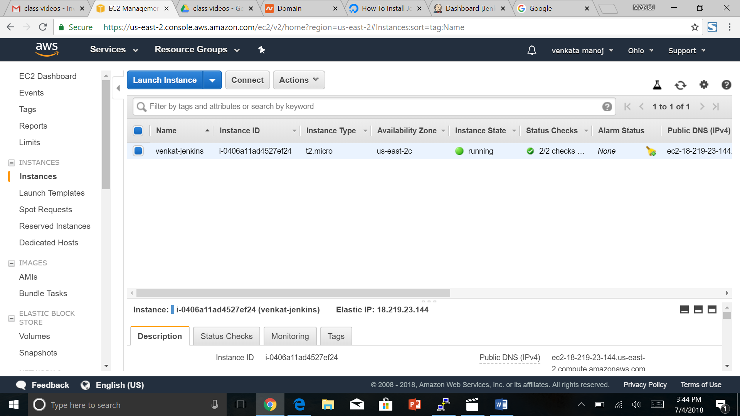

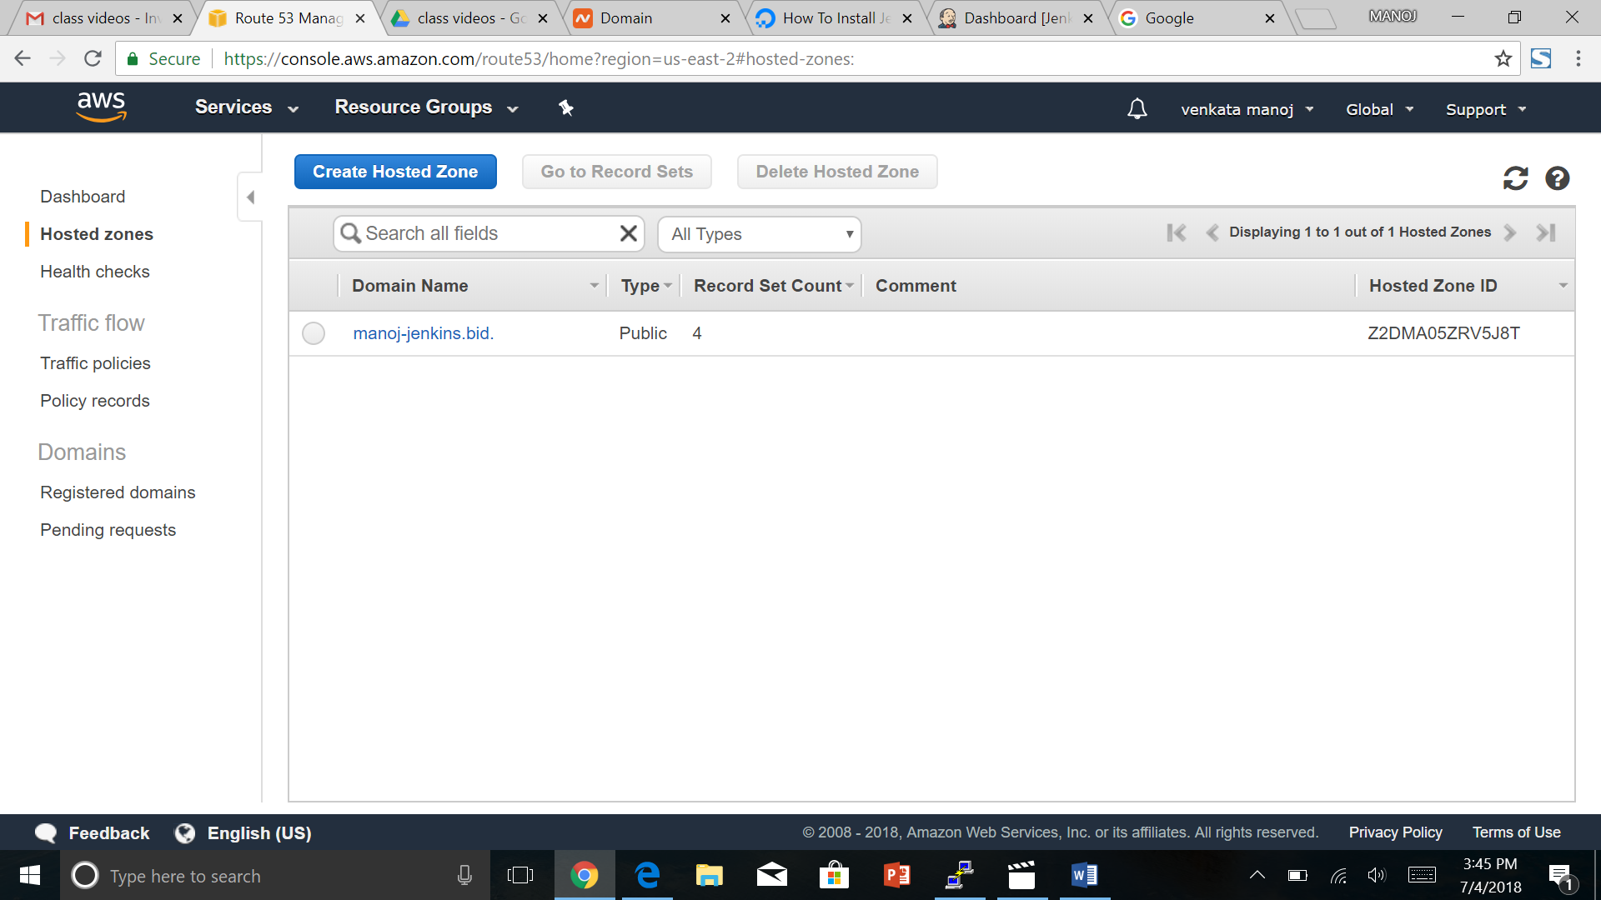

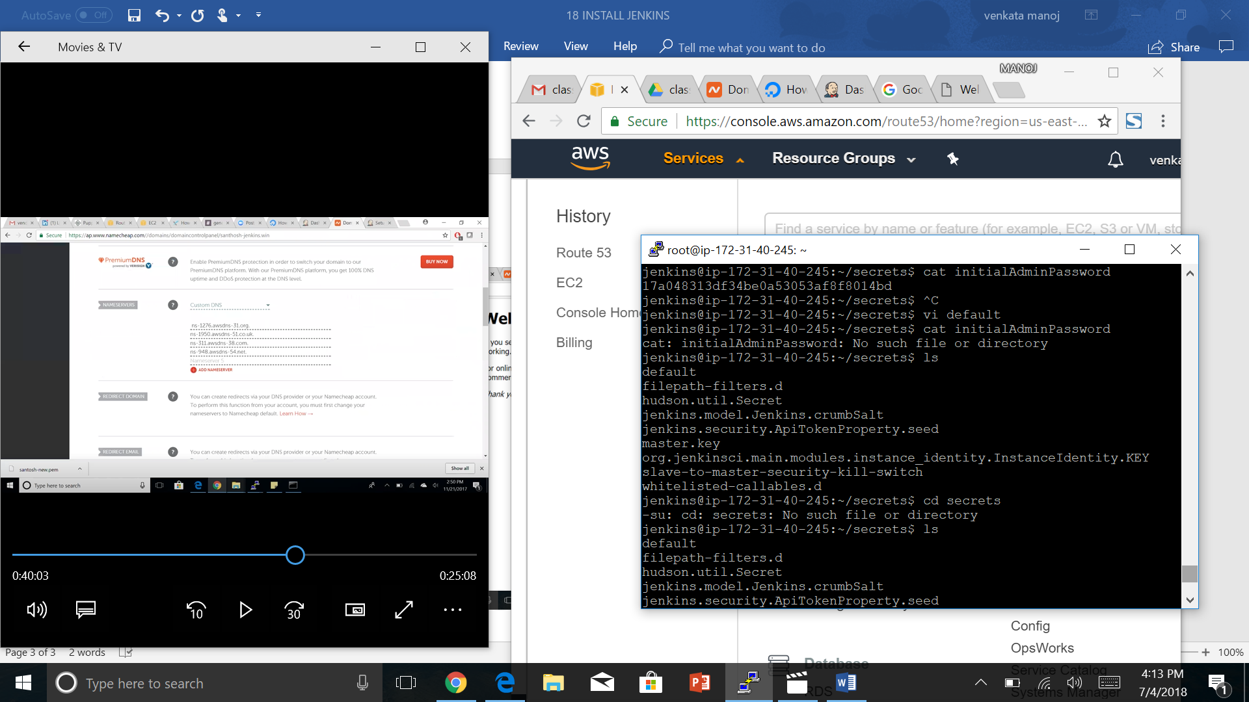

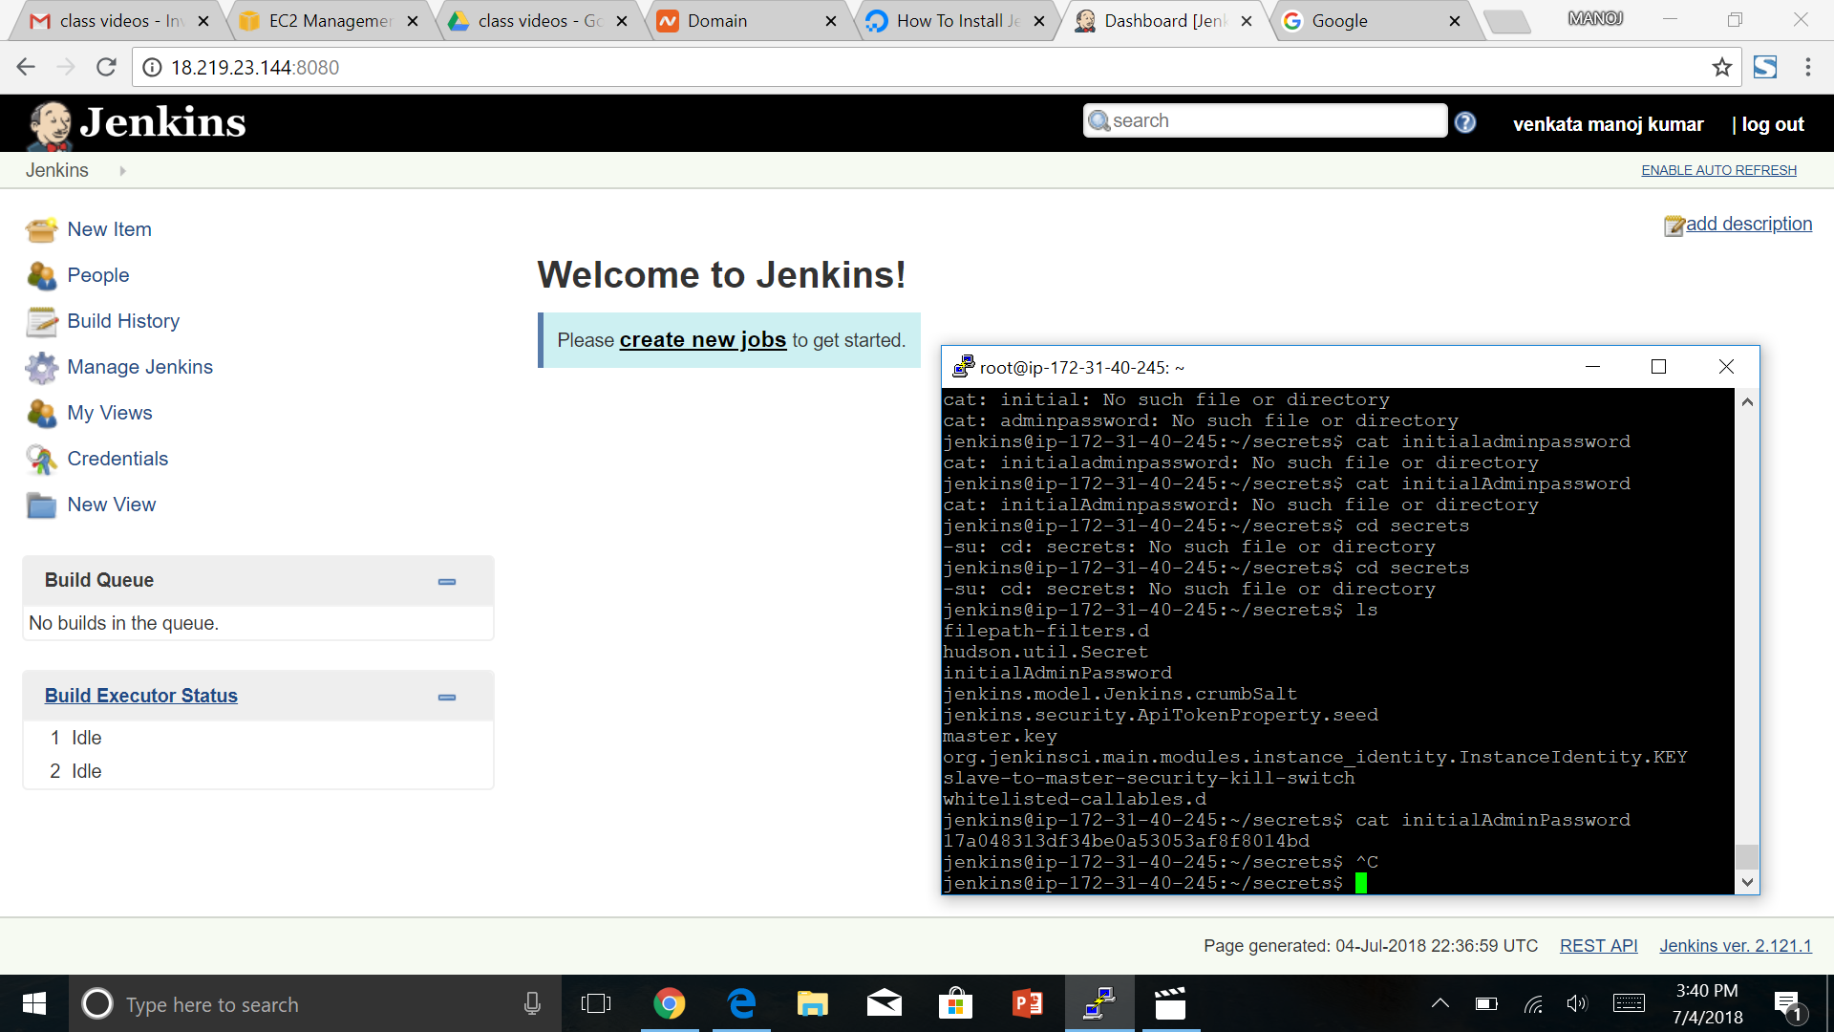

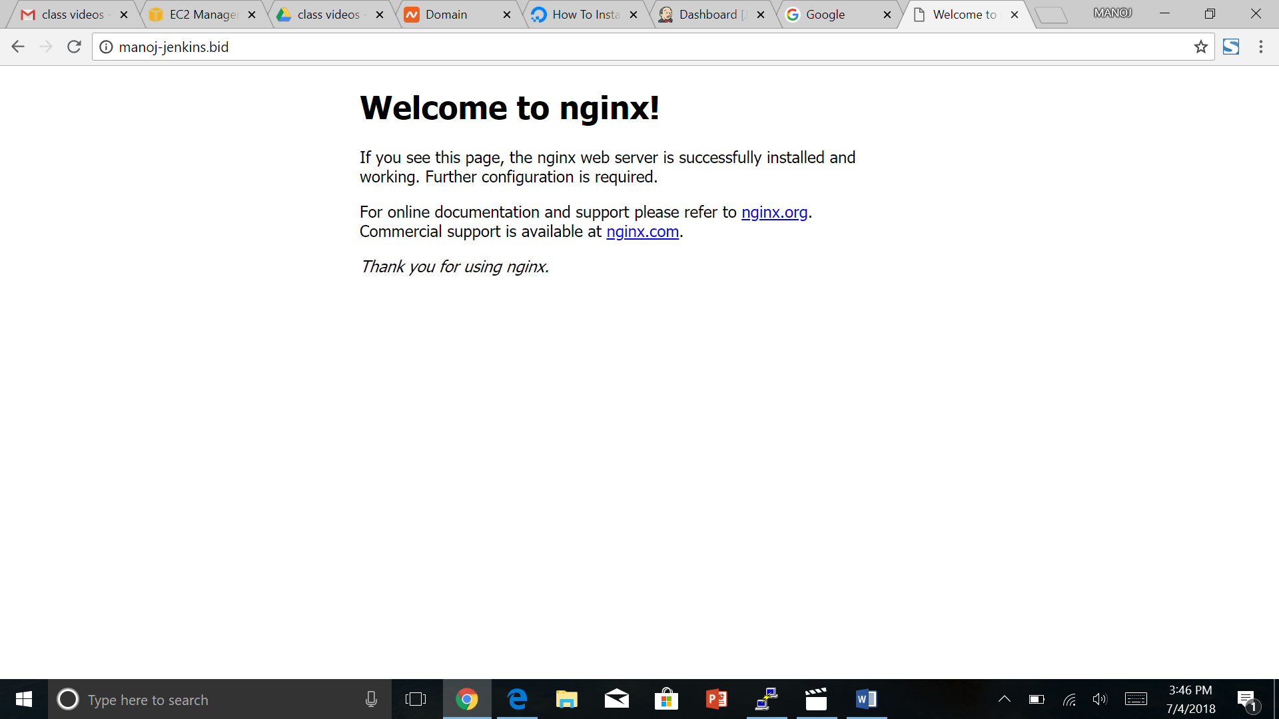

1 apt-get update

2 a

3 apt-get instal nginx

4 apt-get install nginx

5 s

6 apt-get install nginx

7 service nginx status

8 apt-get insatll default-jre

9 apt-get insatll python-software-properties

10 apt-get install default-jre

11 apt-get install default-jdk

12 add-apt-repository ppa:webupd8team/java

13 apt-get update

14 wget -q -O - https://pkg.jenkins.io/debian/jenkins-ci.org.key | sudo apt-key add -

15 java -veresion

16 java -version

17 echo deb https://pkg.jenkins.io/debian-stable binary/ | sudo tee /etc/apt/sources.list.d/jenkins.list

18 apt-get update

19 apt-get install jenkins

20 service jenkin status

21 sudo su-jenkins

22 ls

23 sudo su-jenkins

24 sudo su - jenkins

25 apt-get instal python-certbot-nginx

26 apt-get install python-certbot-nginx

27 cd/etc/nginx

28 cd /etc/nginx

29 vi default

30 exit

31 history

32 sudo add-apt-repository ppa:certbot/certbot

33 sudo apt-get update

34 sudo apt-get install python-certbot-nginx

35 sudo certbot --nginx -d manoj-jenkins.bid

36 service nginx restart

37 service jenkins restart

38 sudo su-jenkins

39 history

root@ip-172-31-40-245:~#